# Proposed Sampling Strategy

Per Team:

3 plots per Fuel Type/TSLF combo (suggested sampling point), at least 50 m apart.

Aim for sampling to take <15 minutes at each plot.

* Set up 20 m transect at least 50 m from road.
* 10 measurements (i.e. every 2 m) along transect of height of each strata
* Cover will be assessed using the point intercept method. Height measurements will be averaged and point intercepts used to calculate % cover. For each point along the transect record:
  + Litter cover, if the ruler touching: 1 = Litter, 0 = Bare Ground.
  + NS and Elevated cover, if ruler touching: D = dead, L = live fuel or N = no fuel.
* Use the provided fuel hazard guide to assess Bark Hazard, the app should auto populate this.
* Measure the height of 3-5 trees using the range finder1. Measure Canopy cover using suggested apps2,3 or visually estimate4.
* Take photos of bark, elevated fuel and general site.

|  |  |  |  |
| --- | --- | --- | --- |
| Fuel Measures | Unit | Fields required | Measurement |
| Near-surface cover | % | tally – hit/miss | Tally - 10 reps |
| Near-surface height ( <0.5 m) | m | 1dec place - | Using ruler, 10 reps |
| Elevated cover | % | tally - hit/miss | Tally - 10 reps |
| Elevated height (0.5 – 2 m) | m | 1dec place | Using ruler, 10 reps |
| Tree height | m | 3-5 individual values | 3-5 Using range finder1 |
| Canopy cover | % | 5 individual values | Use Habitapp2 or CanopyApp3 5 reps per site or visual assessment |
| Litter depth | cm | integer | Using ruler, 10 reps |
| Photos |  | Bark, litter cover, site |  |

1How to use the Forestry Pro Rangefinder <https://youtu.be/SAUL76gEIUo>

2<https://play.google.com/store/apps/details?id=com.scrufster.habitapp&hl=en_AU&gl=US>

3 <https://apps.apple.com/us/app/canopyapp/id926943048>

4Plant cover can be defined as the amount of ground blocked out by that fuel layer if viewed while looking straight down from above. The visual guide below can be used to assist in assessing plant cover. 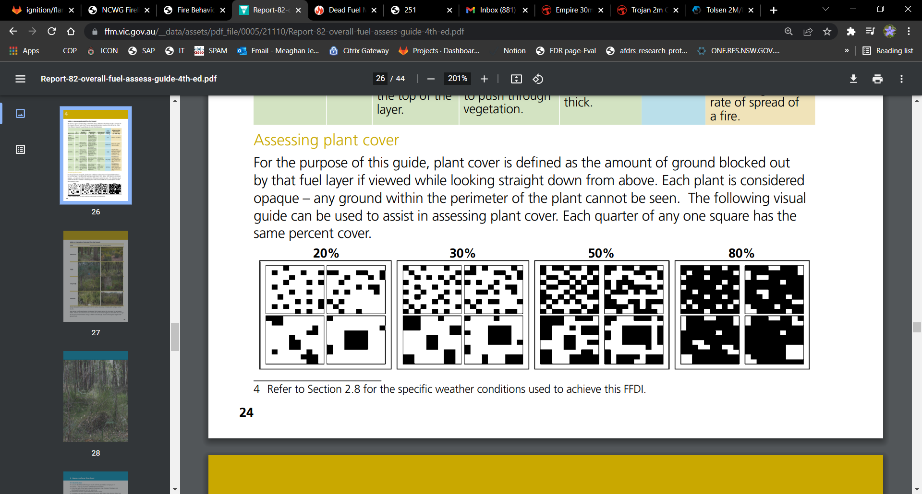

|  |  |  |  |  |  |  |  |  |  |  |  |  |
| --- | --- | --- | --- | --- | --- | --- | --- | --- | --- | --- | --- | --- |
| **Site** |  | | | | | | | | | | | |
| **Date** |  | | | | | | | | | | | |
| **Assessors** |  | | | | | | | | | | | |
| **Lat/Long** |  | | | | | | | | | | | |
| **Fuel type** |  | | | | | | | | | | | |
| **Fire history** |  | | | | | | | | | | | |
| **Rep** | **1** | **2** | **3** | **4** | | **5** | **6** | **7** | | **8** | **9** | **10** |
| **Litter Depth (cm)** |  |  |  |  | |  |  |  | |  |  |  |
| **Litter Cover** |  |  |  |  | |  |  |  | |  |  |  |
| **Surface Hazard** |  | | | | | | | | | | | |
| **Near Surface Height (m)** |  |  |  |  | |  |  |  | |  |  |  |
| **Near Surface Cover** |  |  |  |  | |  |  |  | |  |  |  |
| **Near Surface Hazard** |  | | | | | | | | | | | |
| **Elevated Height (m)** |  |  |  |  | |  |  |  | |  |  |  |
| **Elevated Cover** |  |  |  |  | |  |  |  | |  |  |  |
| **Elevated Hazard** |  | | | | | | | | | | | |
| **Bark Type** |  | | | | | | | | | | | |
| **Bark Hazard** |  | | | | | | | | | | | |
| **Canopy Cover %** |  | |  | | |  | |  | | |  | |
| **Tree Height (m)** |  | |  | | |  | |  | | |  | |
| **Notes** |  | | | | | | | | | | | |
| **Litter cover** | Ruler touching  1 = Litter  0 = Bare Ground | | | | **Near Surface Height** | | | | Fuel Approx. < 0.5 m | | | |
| **NS & Elevated Cover** | Ruler touching  D = Dead Fuel  L = Live Fuel N = No Fuel | | | | **Elevated Height** | | | | Fuel Approx. 0.5 – 2 m | | | |